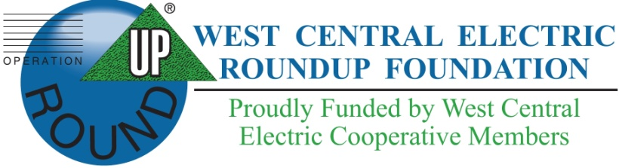
WEST CENTRAL ELECTRIC
ROUNDUP FOUNDATION, INC.

APPLICATION FOR DONATION

Organization: ______________________________________________________________________________

Address: __________________________________________________________________________________

Contact: ______________________________________ Title:_____________________________________

Phone: _______________________________________ Email: ____________________________________

How did you learn of our Foundation? __________________________________________________________

_________________________________________________________________________________________

PROJECT DESCRIPTION
Answers may be attached separately if additional space is required.
All information is mandatory for application to be considered for funding.

Project Title: _______________________________________________________________________________

Project Description: _________________________________________________________________________

__________________________________________________________________________________________

__________________________________________________________________________________________

__________________________________________________________________________________________

__________________________________________________________________________________________

Amount Requested: $_________________

Please describe how funds will be used. Be specific. ________________________________________________

__________________________________________________________________________________________

__________________________________________________________________________________________

__________________________________________________________________________________________

__________________________________________________________________________________________

Please describe the timeline for your project: _____________________________________________________

__________________________________________________________________________________________

__________________________________________________________________________________________

__________________________________________________________________________________________

In a separate attachment, please include an itemized listing of intended funding use. Include dollar amounts. Quotes and photos are encouraged, when appropriate.
If funding is approved, an invoice or statement demonstrating proof of purchase must be received before funds are released.

List other sources of funding for project, if applicable. ______________________________________________

__________________________________________________________________________________________

__________________________________________________________________________________________

__________________________________________________________________________________________

How does your organization measure effectiveness of program(s) and/or use of funds? Be specific. _________

__________________________________________________________________________________________

__________________________________________________________________________________________

__________________________________________________________________________________________

__________________________________________________________________________________________

WEST CENTRAL ELECTRIC COOPERATIVE MEMBERS SERVED

Number of individuals, families, and/or groups served WITHIN Jackson, Johnson, Lafayette, Pettis, and Saline (within the West Central Electric Cooperative service territory) in the past year: _________________________

Specific counties served: _____________________________________________________________________

__________________________________________________________________________________________

Number of individuals, families, and/or groups served OUTSIDE OF Jackson, Johnson, Lafayette, Pettis, and Saline (within the West Central Electric Cooperative service territory) in the past year: ____________________

Specific counties served:______________________________________________________________________

__________________________________________________________________________________________

FINANCIAL INFORMATION

YES NO

Funds exempt from payment of income tax?
If yes, a copy of organization’s 501(c)(3) must be attached.

Is the organization’s 501(c)(3) form attached to the application?

Please provide a copy of the organization’s financial statement(s) from the
most recent year.

Is a copy of the financial statement(s) attached?

REFERENCES

Please list up to three additional organizational contacts, including leadership, volunteers, and/or those directly served or affected by potential funding.

Name: ____________________________________________________________________________________

Title/Role: _________________________________________________________________________________

Address: __________________________________________________________________________________

Phone: _____________________________________ Email: ____________________________________

Does the WCE Roundup Foundation have permission to contact this individual?

Name: ____________________________________________________________________________________

Title/Role: _________________________________________________________________________________

Address: __________________________________________________________________________________

Phone: _____________________________________ Email: ____________________________________

Does the WCE Roundup Foundation have permission to contact this individual?
Name: ____________________________________________________________________________________

Title/Role: _________________________________________________________________________________

Address: __________________________________________________________________________________

Phone: _____________________________________ Email: ____________________________________

Does the WCE Roundup Foundation have permission to contact this individual?

The information contained in this statement is for the sole purpose of obtaining funding from the WCE Roundup Foundation on behalf of the undersigned. Each undersigned understands that the information provided within the application will be used in deciding whether to grant funding, and each undersigned represents and warrants that the information provided is true and complete and that the WCE Roundup Foundation may consider this statement as continuing to be true and correct until a written notice of change is provided. The WCE Roundup Foundation is authorized to make all inquiries they deem necessary to verify the accuracy of the statements made herein.

Incomplete application will NOT be submitted for committee review.

___________________________________
Name of Organization

___________________________________
Signature of Representative
(If school, must be signed by the
Principal or Superintendent)

___________________________________
Date

Please submit this application to:
West Central Electric Cooperative, Inc.
Attention: Roundup Foundation
7867 S. Highway 13
Higginsville, MO 64037

Applications may also be submitted via fax at 660.584.7949 or via email at kim@wcecoop.com

Questions?
Contact Kim Lewis at 816.565.4942

